## Merchant

Demo date: Nov 19, 2024  
Scoping start date: Nov 22, 2024

MSA Signature Date: Nov 26, 2024  
Onboarding Kick Off Date: Dec 5, 2024

[If Exists] Opt Out Date:  
Go Live Date: Jan 6, 2025

GTM POC: Ben  
Implementation POC: Jeff

ERP: QBO

Tax Integration: Other Yes, but not sure what their provider is (likely AST)

### 

### Key people at Merchant

### Main POC: [Owen Gallahue](mailto:owen.gallahue@proton.ai) - Engagement manager (acting CFO until Wilhelm joins)

### CFO: Wilhelm Glaser-Gallion - joining as the new CFO over the next few weeks

### Fiona - Finance at Proton (sends invoices out)

* Pete: VP of Sales

### 

| Notes Sections [Ops International Team to Ignore] *(AE/ Implementation to fill)*   * Info on how merchant bills   They have a seat based usage billing that is fairly common in SaaS but somewhat complex to handle. It can be described as a SaaS seat based billing that maintains a floor of user seats where billing never dips below the floor - more details below.   * Is there any important merchant relationship information? Mostly will be engaging with Owen and Wilhelm  1) What is the merchant temperament?   Merchant is super engaged and very excited about Tabs!  2) Is there a key POC: (i.e.: who is the buyer/decision maker?)  Owen has been our primary POC 3) What are the Tabs features that the key POC cares about?  Tabs building a usage ingest engine to help them streamline processes, as well as get them visibility into |
| --- |

### 

### Company summary *(AE to fill)*

Proton.ai is an AI-powered CRM platform tailored for B2B distributors. It integrates with existing systems to centralize data from transactions, customers, and products. The platform uses machine learning to analyze this data and provide actionable sales insights, such as predicting customer purchasing behavior, identifying sales opportunities, and optimizing sales team efforts. Proton.ai helps distributors increase efficiency, enhance customer interactions, and grow revenue by automating processes and reducing reliance on manual work.

The company's value lies in its focus on distributor-specific challenges, offering features like integration with ERPs, AI-driven recommendations, and tools for managing both inside and outside sales teams. It generates revenue through subscriptions to its CRM platform and related services, targeting mid-to-large-scale distributors across various industries.

Goals (North star)  
*(AE/ Implementation to fill)*

What is the merchant's goal? What pain are we solving? Why are they buying Tabs?

Merchant’s goal is to streamline and automate work on invoicing and revenue recognition, and get greater visibility into Forecasting and MRR.

**Pain points**

Manual processes:

Renewals and seat updates are manually tracked in Salesforce, and invoicing/revenue recognition rely on QuickBooks and Excel, leading to inefficiency.

Scalability Issues:

As the customer base grows, current systems struggle to manage complexity, especially with variable contracts and new logos.

Revenue Capture Gaps:

There are challenges in capturing revenue effectively and appropriately tracking forecasting and MRR due to lack of automation and stable process.

Is there an opt out clause? If so, what is the merchant looking for so they do not exercise it?

No opt out

### Billing model *(AE/ Implementation to fill)*

* Are there unique things about the customer creation process for this merchant?
  + No
* Information on how merchant bills

SaaS seat based billing that maintains a floor of seats - simple in concept but somewhat complex to support:

* They bill a software fee based on seat count which includes a specific number of seats. This number of seats becomes the "floor" of their contract. For example, their customer BPI signed a contract with 45 seat "floor" to start.
* When a new seat is added above the initial seat count, for example if BPI added two new users, that new seat count of 47 users becomes the new floor.
* The new seats are billed for the remainder of the annual term, pro-rated for the rest of the contract. IE if BPI adds a new seat 3 months into an annual contract, they bill for the remaining 9 months up front
* They have price breaks for additional users at certain thresholds, once the BPI seat count reaches 50 seats, price per new seat goes to $130/seat/month. At 75 users, it goes to $105/seat/month, and so on

We’ve worked with Arjun on how to support this use case, will discuss more during our pre-kickoff meeting

* How contract is broken up

Contract has an initial purchase of a specific number of seats that is specified as a dollar amount. There is then a tiered pricing table for additional seat purchases

* One off things to know about the merchant

The merchant will be revising their billing model, and us planning to experiment with new pricing models. They are interested in our thought partnership on best practices!

### Contract Processing Steps *(Ops to fill)*

1. Steps to process net new contracts (if it is a renewal contract but no customer exists yet or a customer exists but doesn’t have a contract that ties to the renewal, treat the contract as net new)
   1. Find billing terms in order form table
   2. Service start date = effective date
      1. If multiple years, service start dates will correspond to that year.
      2. For example, year 2 service start date would be effective date + 1 year.
   3. Total months of service will be stated under initial term
      1. If specified as a one-time payment, months of service will be 0
      2. If not specified as a one-time payment, and no other indication of term length, use best judgement.
         1. For example, for professional services fee with fixed quantity, this will likely be billed one time upfront and should be 0 for months of service.
      3. If multiple years, total months correspond to that period for that BT. For example, year 1 and year 2 would each be 12 months unless it is specifically mentioned that the invoice cadence is different.
         1. For example, if the first 3 years (see below screenshot) are invoiced together, the months of service would correspond and be 36 months.
   4. Item name will be under Proton Services (or similarly named) column
   5. No item description
   6. Will more than likely be a Flat BT, unless there is no quantity or total price stated
   7. Total price will be total price
   8. Quantity will be quantity, if listed
   9. **Invoice cadence will most often be under “Payment Terms”.** Follow the cadence listed to determine billing start date, # of periods and frequency.
      1. For example, quarterly invoicing will be sent on effective date and will recur once every 3 months until term end
   10. Net terms will likely be under “Payment Terms” as well
   11. BTs to add as well (look out for any other than aren’t listed under BTs to ignore)
       1. eCommerce fees, unless they are baked into the larger annual subscription cost. (see below screenshot)
   12. BTs to ignore
       1. Anything under Services Package (will be an hourly rate)
       2. Incremental User License Fees / Rate Table (the tiered rate table)
       3. Workflow Connector Fees
       4. Discounts: no need to process discounts. Just take the final price. If unsure how the discount applies to the individual BT, please raise the US team.
   13. For contracts that look like the below (they are more rare)

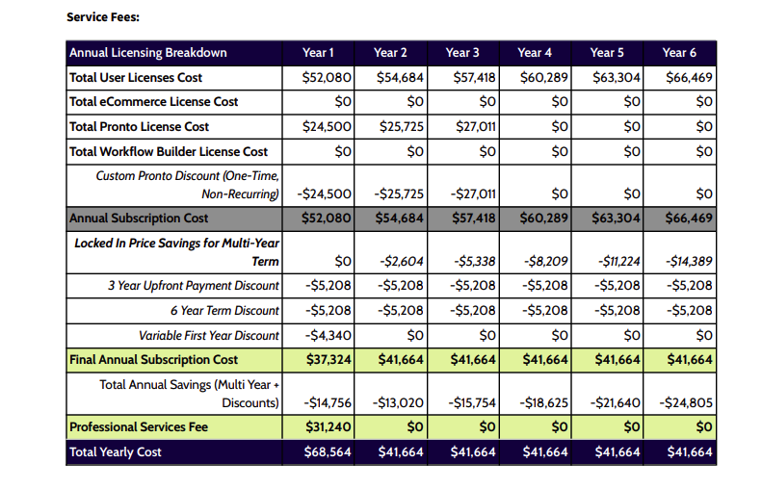

1. The only BTs here would be final annual subscription cost and professional services fee
   1. No need to process any discounts
2. In this contract, the “Payment Terms” section specifies that the first invoice will be the first 3 years in one, and then each individual year thereafter.

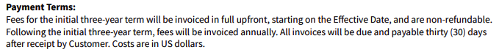

* 1. So there will 5 BTs in total
     1. The first: a sum of Year 1-3 Final Annual Subscription Cost
        1. Total price = 37,324 + 41,664 + 41,664 = 120,652
        2. Service term start date = effective date
        3. Total months of service = 36 (3 years)
     2. The second, third and fourth: each Annual Subscription Cost for each year
        1. 41,664 each
        2. Service term start date = start date of each year
        3. Total months of service = 12 months for each
     3. The third: Professional Services
        1. 31,240
        2. Service term start date = effective date
        3. Total months of service = 0
* **Renewal contracts** will be processed under the original contract if it modifies the original contract, which will often be the case.
  + As stated, if there is no original contract to process anything under, treat this as a net new contract and follow the instructions above OR if the renewal contract doesn’t modify the original contract and the dates don’t overlap, process the BTs under the renewal contract (be sure this is the case if you follow this option)
  + Service start date for the renewal BTs will be the effective date of the renewal. Said another way, the renewal BTs will have a new revenue recognition period that corresponds with the new effective date and service length and is different than the original contract.
  + After processing the renewal under the original contract, mark the original contract as processed in garage
  + If the renewal contract *overwrites* the terms of the original contract, you will need to modify the existing BTs under the original contract in addition to adding new BTs
    - Example
      * [Renewal](https://garage.tabsplatform.com/prod/contracts/2bc817f3-681d-4970-9894-7c938e0fbbe4/terms/key)
        + “This Order Form Supersedes and replaces the 36-month Order Form Executed on 5/23/2024 by both parties.”
        + In this case, the renewal overwrites the last 24 months of the original contract, so we have to go into the original contract and delete those BTs. The BTs for the first 12 months of the original contract will be left alone.
        + Here, we have added the annual payment BTs created by the renewal contract
      * [Original](https://garage.tabsplatform.com/prod/contracts/ef9b0dd2-ee1b-45c8-a9be-3f213d00bf63/preview) for reference
* **Processing upsells**

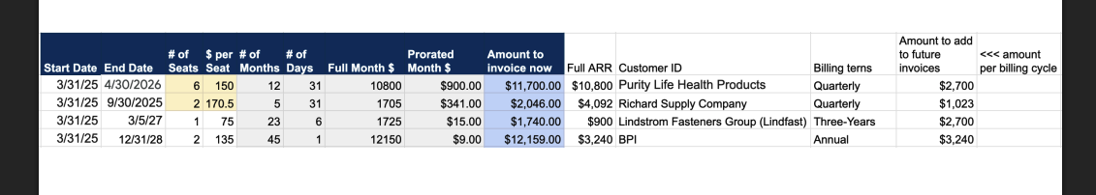

* + What the garage upload will look like [LINK](https://garage.tabsplatform.com/prod/contracts/865cac76-70c5-46f5-ac96-e2785d4e6bcb/terms/key)
    - Process this without a customer assigned or any BTs
  + What we are doing with this table:
    - Altering the BTs for the relevant corresponding contract for each customer listed
    - First, we are creating a one time amount to be invoiced on the start date column
    - Second we are adding the specified amount to future BTs occurring after the listed start date
      * This is why we create separate BTs for each invoice
    - An example for Purity Life (not actually the case but just illustrative)
      * Has 4 separate BTs in the original contract for user license quarterly payments
        + User licenses $7200 Nov 1, 2024 - Jan 31, 2025
        + User licenses $7200 Feb 1, 2025 - Apr 30, 2025
        + User licenses $7200 May 1, 2025 - Jul 31, 2025
        + User licenses $7200 Aug 1, 2025 - Oct 31, 2025
      * Using the screenshot above
        + We see the start date is 3/31/25
        + The amount to invoice now (blue highlighted column) is $11,700
        + The amount to add to future invoices is $2,700
        + # of seats is 6 - we only use this for the one-time payment. No need to change exist BT quantities
      * So we will first add the one time BT of $11,700 with billing and service date being 3/31/25
        + Frequency none
        + Item name: User licenses
        + Description: March upsells
        + 0 months of service
        + Quantity 6 (number of seats)
        + Integration item: Access to web portal
      * Next, we will add $2,700 to each existing BT that occurs after 3/31/25
        + Looking at our list of 4 BTs, we will see that will only be the May 1 and Aug 1 BTs
      * So our new BTs will be
        + User licenses $7200 Nov 1, 2024 - Jan 31, 2025
        + User licenses $7200 Feb 1, 2025 - Apr 30, 2025
        + User licenses $9900 May 1, 2025 - Jul 31, 2025
        + User licenses $9900 Aug 1, 2025 - Oct 31, 2025
        + User licenses $11,700 Mar 31, 2025

Integration item mapping

* Anything related to Annual Subscription or User Licenses, use Access to Web Portal
* For Professional Fees, use Professional Service Fees
* For Ecommerce Fees, map to E-Commerce API
* Standard Services Package will be Professional Service Fees

1. Specifics processing things the merchant has requested that may differ by contract (e.g. always back-date invoice date to final day of the month)
2. Default Service Term
   1. If None Listed, Ops Default is 1 Year
3. Default Net Payment Terms
   1. If None, Ops Default is 0
4. Default Billing Frequency
   1. If None Listed, Ops Default is Monthly
5. How do we handle taxes as a line item?
   1. If None Listed, Ops Default is every tax line item becomes a BT

### Events Processing (if necessary) *(Implementation/Success to fill)*

* Any important information on events billing

Integration Items Processing (if necessary)  
*(Implementation/Success to fill)*

* What are the instructions for assigning integration items?
* Example: All Statsig integrations items should be labeled as “Sales”
* Example: All “Pinata” integration items should be labeled as “Software Subscription Bundle” unless otherwise noted by Merchant

Post Processing Communications (if necessary)  
*(Implementation/Success to fill)*

* Does the Ops Team need to notify anyone on the team re: completion of processing batches in Implementation or Active phase?
* Who needs to be notified and when?
  + Example:
    - Who: Customer Success [Azmat Aziz] needs to be notified
    - Where: Messari internal merchant channel
    - When: contracts are processed [Merchant Phase: Active]

### Customer Information *(Implementation/Success to fill)*

* Any important information on specifics customers of this merchant
  + Special memo’s certain invoices require
  + Invoice changes due to merchant/customer relationship

### Feature Requests *(AE/Implementation/Success to fill)*

* FR 1
  + What is it
  + Why it's important
  + Urgency

### Rewatch Calls *(AE/Implementation/Success to fill)*

* <https://tabs.rewatch.com/video/13vsjrj6taiu3553-owen-benjamin-meeting-november-19-2024>
* <https://tabs.rewatch.com/video/3yy0uhayvisxvv2d-tabs-proton-custom-demo-november-22-2024>
* <https://tabs.rewatch.com/video/3mmj6qcv9okx0mej-tabs-proton-november-26-2024>